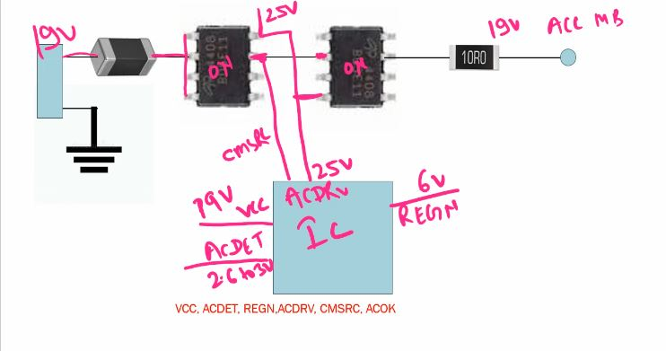
- VCC
- ACDET
- REGN 6V (ic internal work ok)
- ACDRV (to switch on mosfet)
- CMSRC – mosfet on feedback
- AC OK – sio feedback
How to Find VIN Section in Schematics
ACP, ACN – Current measurement of CLR
VCC/DCIN – IC Power Supply
ACIN, ACOK – Output Pins (3.3 volt pull ke throug)

Send msg to SIO that adapter supply CLR par pahuch gya hai(adapter or battery supply is stable)
ACDET – 2.6-3.0V Valid adapter insert hai ya nhi…
ACDRV – mosfet ko on krne keliye.
CMSRC – dono se source se connected, mosfet switch on feedback
REGN ~6V -VCC/ACDET valid hai to, (IC internally ok hai to)
SRP, SRN – CLR for battery current measurment ke liye.
NOTE
P-Channel Mosfet me ACDRV nhi hota hai kyu ke 25 not required
P channel low voltage = ON
G=S OFF
Random
Open Drain
Close Drain

